SEMINAR ANNOUNCEMENT
A Live Demonstration of Agentic AI in Biochemistry
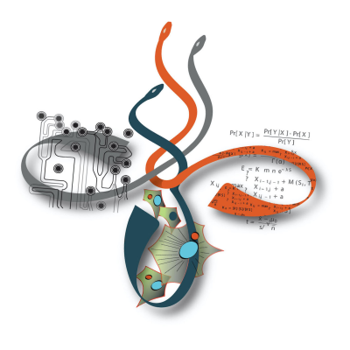 | Mike Hallett  Department of Biochemistry, Western University  www.mikehallett.science

The Demonstration
You’ve finished generating the data underlying a project in your lab and are ready to start the analysis. Where do you start? Perhaps you have little experience with stats and even less with programming? Perhaps there are other datasets in the literature that you would like to compare to? How do you organize yourself in this next phase of the project? What can you do in an hour?
I will give a demonstration of Claude Code, Anthropic’s agentic AI coding system, using an example challenge: can we predict whether an arbitrary small molecule drug can penetrate the blood-brain barrier (BBB)?
We will watch Claude Code autonomously plan, summarize literature, execute, debug, cross-validate and visualize an end-to-end analysis pipeline in real time using my favourite four sub-agents working in parallel: the BLACKSMITH who performs analysis, the BOOKWORM constantly surveying the literature, the ARTIST who expresses the findings, and the ADVERSARY who is forever skeptical.
The Science: Characterizing molecules that cross the Blood-Brain Barrier
I think everyone in the department should be able to understand the basic goals of this challenge, making it a good vehicle to showcase Claude Code.
We will pretend that we generated the data from Shaker et al. (2021, Bioinformatics); this is a large set of molecules which were measured for their capacity to breach the BBB. The BBB is one of the most consequential gatekeepers in drug discovery - a molecule that cannot cross it cannot treat neurological disease, while one that crosses unexpectedly may cause dangerous CNS side effects. Predicting BBB permeability computationally from molecular structure is therefore a high-value target sitting at the intersection of cheminformatics, AI, and neuropharmacology.
The BLACKSMITH will develop from scratch a user interface (GUI) to explore these molecules and build a classifier able to predict if a compound will traverse the BBB. The BOOKWORM will query external chemical databases like ChemDB to annotate predictions with real-world drug information and monitor a Slack channel. The ARTIST will design informative plots and prepare a PowerPoint of the findings. The ADVERSARY will constantly be assessing correctness, challenging our findings and cross-validating.
All orchestrated from a natural language prompt without writing a single line of code - in 50 minutes.
Why You Should Come
Claude Code’s agentic capabilities extend far beyond coding — it can summarize literature, organize project files, perform data analysis, generate reports, and coordinate workflows. My goal is to show how future AI-assisted science may look and leave you with concrete ideas for how these tools can be applied to your research now.
Techniques such as these are actively being incorporated into companies such as Genentech where “Lab in the Loop” protocols –deeply rooted in AI– underpin work-environment revolutions and social engineering.
This seminar is designed for researchers at all levels of computational experience: a biochemist who has never opened a terminal, someone curious about AI-assisted research, or a seasoned bioinformatician who wants Claude Code tips.
EVENT DETAILS
Date & Time: TBA | Location: TBA | mailto:michael.hallett@uwo.ca

